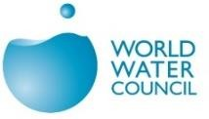

9e Forum Mondial de l’Eau, Dakar 2021

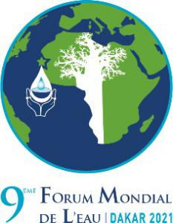

Concept Note on « Water Security », as Priority 1 of WWF 9

by

S. Diop, Professor of University/UCAD and Member of Senegal National Academy of Sciences
and
- Kane, Professor of University/UCAD

- As an introduction, examples around the world indicate that « Water Security » can only be primarily achieved in an environment characterized by Peace, Security and Cooperation. Whether in the Middle East/Jordan, Syria, in Europe/Danube, in Asia/Indus and Mekong, in Africa/Nile River and Lake Chad, or in the Americas/Laurentian Great Lakes, when peace and cooperation prevail, they provide an enabling environment for ensuring water security. Indeed, neither political tensions nor conflicts with disputes and violence environment can support achievement of « Water Security ». Therefore, this reality is critical to bear in mind at all times and in all discussions during the WWF9, Senegal’s proposal focused on “WATER SECURITY FOR PEACE AND SUSTAINABLE DEVELOPMENT, with COOPERATION as the overarching theme.” Moreover, cooperation in pursuit of sustainable development is important for Senegal since the country is a party to two shared rivers basins, Gambia and Senegal.

- Water itself is essential for all life on our planet, including the associated social and economic activities that define humanity. As we all know, water is the most encompassing global-scale integrator connecting aquatic and terrestrial ecosystems and the atmosphere in a continuing cycle of use and replenishment. Further, adequate supplies of freshwater of suitable quality are an absolute requirement for all life and socio-economic development.

- What do we mean by « Water Security » ? This Forum is referring to the UN-water definition, including IHP of UNESCO, which is as follows: « the capacity of a population to safeguard access to adequate quantities of water of acceptable quality for sustaining human and ecosystem health, and to ensure efficient protection of life and property against water- related hazards such as as floods, landslides, land subsidence and droughts ». Thus, Water Security addresses not only the threats to human societies posed by floods, droughts and pollution, but also includes the impacts of inadequate supplies of water, both in quantity and quality, for their critically- important rôle in food and energy production, for human domestic and industrial purposes, and for sustaining ecosystem productivity. Indeed, Education as a whole is key to address « Water Security » issues extensively covered through SDG Goal 6 and related goals in all its aspects in a sustainable manner.

- Accordingly, to fully consider the « Water Security » concept, we must take into account the water cycle in its entirety (lakes, dams and other impounded waters, rivers, groundwaters, wetlands, floodplains …), including the environmental, social and economical aspects, the need to promote an integrated approach to the management of water resources, and seeking to overcome sectoral and regional fragmentation.

- Recognizing water’s critical role in supporting human health, livelihoods and economic growth, this Forum has elevated water to a high priority in the agenda of our planet, particularly the important issues related to water supply and sanitation, and to the water-energy-food-health nexus. Indeed, water is both an ecosystem ‘good,’ providing drinking water, irrigation and hydropower, and an ecosystem ‘service,’ supplying water to people whether they are aware of it or not. The reality is that water is directly or indirectly important for almost every economic sector, including agriculture, manufacturing, trade, mining, tourism and transport. Further, water-related ecosystem functions include nutrient recycling and supporting habitats for fish and other aquatic organisms, as well as ‘cultural services’ such as scenic, recreational and spiritual opportunities. The prospect of improving human well-being, therefore, is critically dependent on our capacity to respond to water-related environmental changes – particularly climate change - which increases the risks and reduces opportunities for human development and poverty alleviation. Because of the complexity of these challenges, responses must focus on the root causes and underlying drivers of such changes and issues, rather than only responding to symptoms.

- In the case of Africa, although there are many implications regarding climatic variability and change, one of the key consequences will be the impacts on water resources and hydrological systems, affecting water availability and, in a nutshell, « Water Security » as a whole. These effects will negatively affect water provisioning, as well as rain-fed agricultural productivity in many parts of Africa as a whole, with more or less important variances occurring in specific places and localities. Various other changes and modifications, some likely yet unknown, are likely to occur in response to a great variability in the global climate system, including extreme aridity in some cases, and flooding in others. It is clear, therefore, that integrating climate change risks and opportunities into the development decision-making process is a key challenge facing the African continent, particularly for the most vulnerable countries if we want to ensure « Water Security » as a whole.

- Because climate change in Africa is projected to result in significant changes in the demands for, and availability of, water resources, addressing climate change impacts is critical because not only is it adding to the existing pressures of development on limited water resources, but that they will do so in the face of growing populations and economies as climate change pressures intensity, placing yet greater stresses on existing water resources. Thus, the challenge of managing water resources in Africa over the coming decades becomes both a climate change and development challenge.

- Despite the principle of common, but differentiated responsibility as defined under the UNFCCC, the question to be addressed is how will it be possible to take into account some form of equity in the campaign against climate change impacts; hence, the following argumentation is germane, as it has tremendous impacts on addressing climate change impacts on the limited water resources in Africa:

“Can Africa really fund its own responses to climate change impacts as unconditional contributions using domestic resources, irrespective of how marginal this could entail? As Africa is the only global region bearing the greatest burden of climate change, did Africa over-pledged and how feasible is it for African countries to internalize their NDCs in its current form, including taking into consideration Africa’s water resources? Is it ethically and morally acceptable to further risk the impoverishment of many more people by deploying scarce national resources for the implementation of NDCs?”
J. Nkem (2016) in “Unpacking Africa’s enigma with NDCs; September 2016; Science*Policy*Africa; Page 14 and 15”;

- The significantly increasing populations in developing countries, and their transitional economic developmental needs, also requires sufficient and stable freshwater resources. To this end, rivers and groundwater resources, but also lakes and reservoirs are readily-usable sources of large volumes of freshwater which, if properly managed, are significant water supplies for these populations and their health and continuing economic growth. A related concern is the impact of aging infrastructure in regard to water storage and delivery from these lentic water systems, an issue of obvious importance to both developed and developing countries.

- To ensure « Water Security » as a whole, the potential threats to ecosystem integrity and transformation resulting from degraded water resources, particularly lakes and réservoirs, also merit consideration in regard to maintaining the sustainability of their wide range of ecosystem services to humanity. To sustain, manage and restore their water resource values, we particularly must take into account the common, but unique, features that define these lentic waterbodies, including their integrating nature, long water retention time and complex response dynamics that collectively translate into the challenges for humans to overcome technologically and managerially. Our past achievements unfortunately have been far less than satisfactory. These lentic waterbodies and their associated systems have been continuously and consistently degrading over past decades, if not centuries.

- The Following perspectives and expected results could be envisaged and discussed during the Forum:

- Because of the overall magnitude of critical issues related to « Water Security, » and to move concretely into development and implementation of « actionable » programmes, it will be appropriate to select some key outstanding priorities, among which:
- The importance of water infrastructure in addressing critical water security threats including floods, droughts, inadequate water supply and sanitation, etc.
- Shared waters/transboundary waters and impounded lakes and reservoirs;
- Water and ecosystems, including restoration of degraded system, assessment of the timing, magnitude and pattern of suitable water quantity and quality aspects and needs;
- Consideration of the water-food – energy – health nexus within the context of climate change;
- Innovative financing mechanism and aid program to alleviate the burden on African countries in implementing NDC and achieving water security and SDG.
- Water Efficiency as a key solution to water stress in the context of climate change and population growth.
- Environmental security and ecosystems, including Nature-Based Solutions to maintaining life-supporting ecosystem goods and services, integration of the management approach concerning mountains, river, forest, farmland and grassland.
- Territorial security (risk of water related conflicts, mainly in various localities and cities, as tensions and conflicts are appearing within the localities themselves). Ultimately, and between riparian territories and countries, true dialogue and cooperation at all institutional levels should be priviledged, including the exchange of information and data on water resources security and development, since instead of being considered as an environmental issue, water resources are being regularly treated as a security issue; hence, the émergence of the concepts of hydro-policy and hydro-diplomacy.
- Education, training, capacity development, including R&D and STI and engineering, remain critical pillars in regard to sustainable water systems, their resources and their basins ;
- The need to provide tentative answers to some key questions, examples being which priority programs with which priority actions and priority investments for « Water Security » and sustainable development, particularly in Africa and in developing countries in general, should be pursued, developed and implemented, and how can these goals be most readily achieved?

As far as Senegal is involved in these efforts, one of the main outcomes of this WWF should be inclusive of a creation of a Hub for Peace and Security, using transboundary waters sustainable management as a good exemple for ensuring « Water Security » in the continent; e.g., OMVS ;
This Hub should be facilitated and reinforced by implementation of water citizen science national and regional networks in order to sustain the notion of « Water Security », crucial for a long term socioeconomic development of our countries.

With 80% of Africa’s water resources being transboundary in nature, this overarching theme is very important for Africa, with investments in infrastructures and environmental monitoring systems requiring cooperation planning and coordinated implementation at the basin level. This reality is also important for addressing water basin issues in Asia, Americas and Europe. It requires the development of appropriate institutions, addressing the associated range of complex legal and organisational aspects. Because Senegal situated within two river basins; namely the Gambia and Senegal rivers and lake basins, transboundary cooperation for water security peace and sustainable development is crucial. In this regard, two best water management practices examples in Senegal should be consolidated ; namely, Lac de Guiers and the shared river basins/transboundary rivers of Senegal and Gambia.

What approach is appropriate for running the WWF sessions ?
- identify 5-10 key thematic areas for presentations and discussions under suitable expert panels(the number of sessions depends on the interest of participating organizations and the availability of venues);
- Interactive and inclusive dialogue and information exchange, including keynote speech, case presentations and panel discussion;
- Potential participants include representatives from national governments, development banks, research academies, donor agencies, business community and civil society.
- Public participation in the interactive dialogue on « water security ».
Lakes, reservoirs and impounded waters : Two examples of « Water Security » management best practices for peace and cooperation at national and regional levels ; the Lake de Guiers and OMVS
Lakes and reservoirs are also inadequately managed and conserved, partly because of sectorally-based management approaches that create conflicts of interest attributable to inadequate appreciation of their inter-connectedness and inter-dependency, thereby highlighting the need for a broader, more comprehensive management perspective.
In fact, lakes, dams and other impounded waters contain more than 90% of the readily-accessible freshwater on planet’s surface, as well as providing a wider range of ecosystem goods and services than other freshwater system. Their accurate assessment, management and conservation, therefore, is a fundamental requirement to ensure their sustainability in meeting human and ecosystem water needs now and into the future, as well as having a mitigating function in addressing the hydrologic uncertainties associated with climate change.
Restoring a seriously-degraded lake environment to its former condition is difficult, and the range and magnitude of its ecosystem services diminishes markedly during its degradation. Lakes and reservoirs also possess unique assessment and management challenges (long water retention times; integrating nature; and non-linear responses to stresses) not addressed by currently-used management approaches such as Integrated Water Resources Management (IWRM) and Integrated River Basin Management (IRBM).
As a result, despite past efforts to manage lakes and reservoirs and their resources for sustainable use, they remain very vulnerable to the impacts of human activities, with their overall condition deteriorating on a global scale, thereby exhibiting serious threats to their Human Water Security and Biodiversity values, and serious potential consequences to many lake-related ecosystem services.
Management of a Strategic Water Reserve: Case of the Lake de Guiers system
Lake Guiers is located in the delta on the left bank of the Senegal River, south of the town of Richard-Toll. It is the main surface freshwater reserve of Senegal, occupying an area of 240 km², with an average volume of 390 million m³, which can increase to 600 million m³ at the conclusion on ongoing major work projects. This important water reserve is utilized for multiple purposes, especially for irrigation, the production of drinking water for the agglomeration of Dakar (50%) and some secondary cities in the country, and for livestock watering.
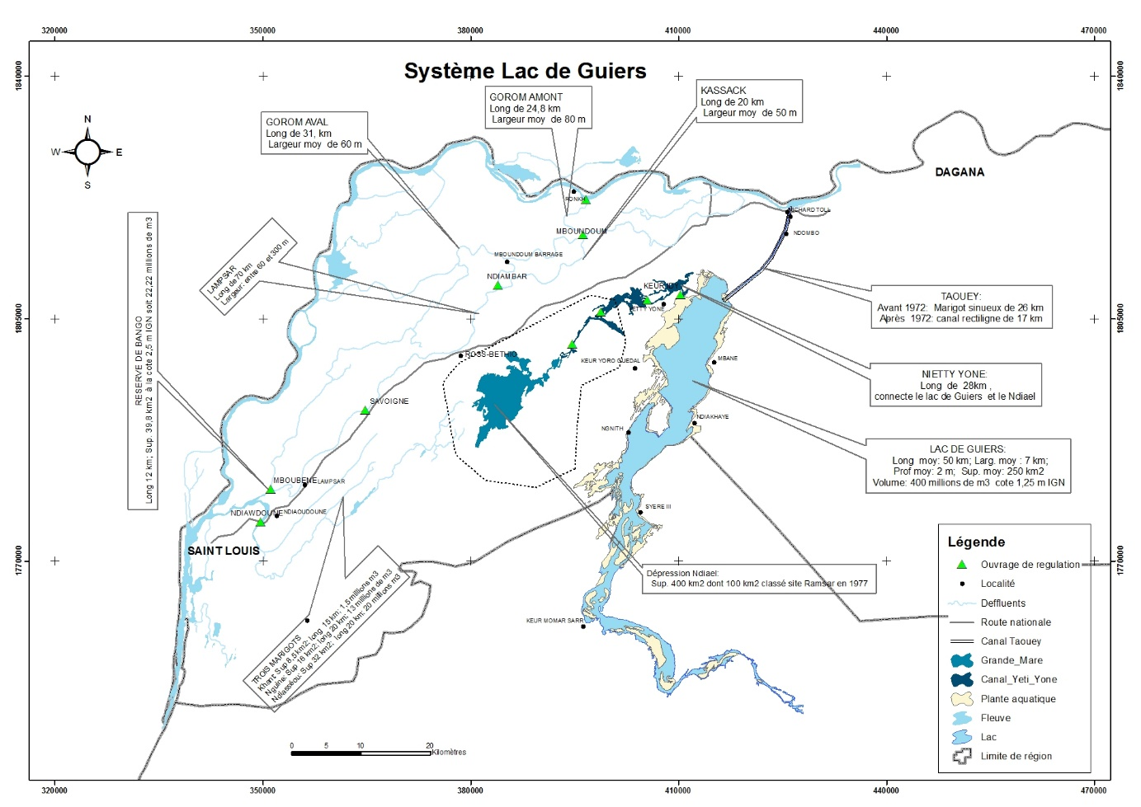
Lake Guiers is part of a complex system called the Guiers fluvio-lacustrine system. In addition to Lake Guiers and Taoué, it includes the Ndiael and the lower valley of Ferlo, whose next watering will be vital for wildlife and the flora of these two ecosystems that must be restored. The lake is connected to the Senegal River by the Taoué, a 26 km adductor that has recently benefited from dredging and weeding by the Office of Lake Guiers (OLAG).
The two dams of Richard Toll and N'Dombo were constructed on this canal, which regulates the water supply of the lake from the Senegal River and improves the operating conditions of the pumping stations of the Compagnie Sucrière Senegalese, which ensures the supply of sugar from the local market.
The conditions for the exploitation, management and safeguarding of the lake's water resources have been greatly improved with the implementation of the economic and economic functions restoration project (PREFELAG).
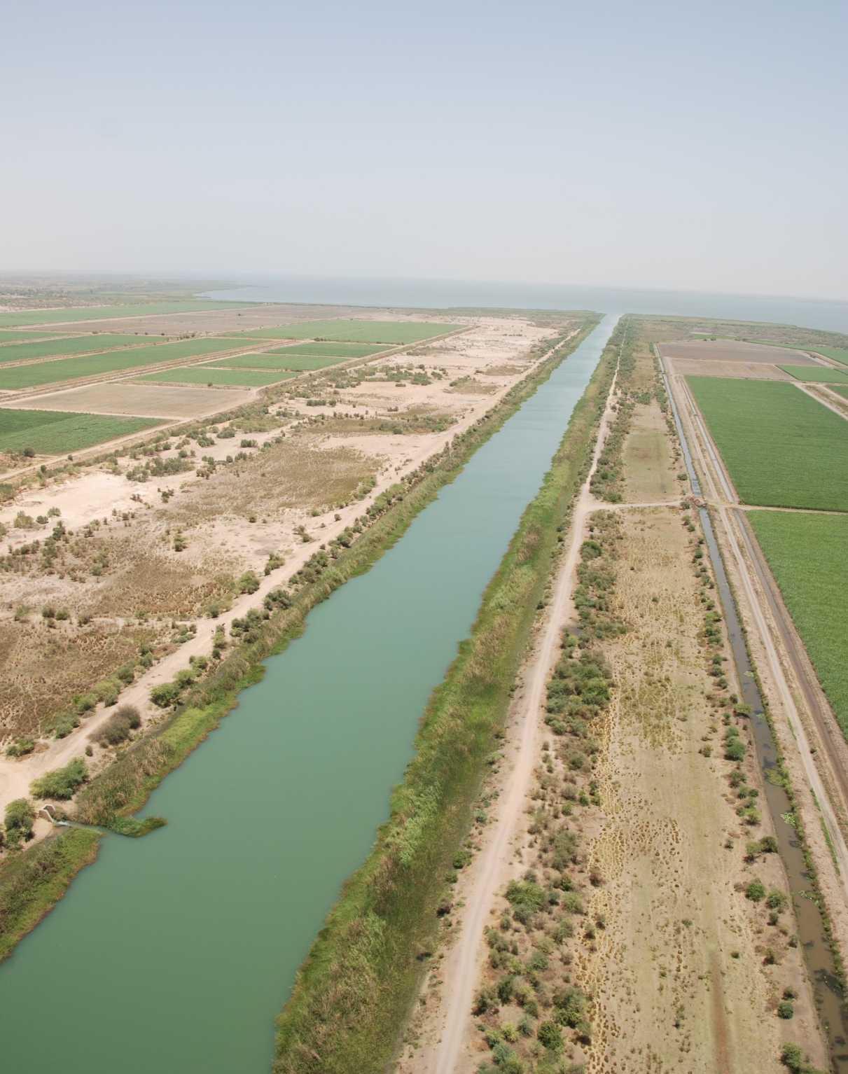
The Lake Guiers Office has established the strategic water transfer project of the Guiers Lake Reserve inland (PREFERLO) in order to meet the water needs of the grain corridors, the populations, livestock and ecosystems in the agro-silvo-pastoral zone of Ferlo. Thus, it is a challenges of meeting the water needs of the deficit areas of the country in which most of the economic activities are concentrated, as well as more than 70% of the country’s population.
Implementation of this project, in addition to valorizing the agro-sylvo-pastoral potential and the ecosystems of Ferlo and Ndiaël, will have a notable impact on the economic and social development of the area, including fixing the young people in their territories with the creation of jobs.
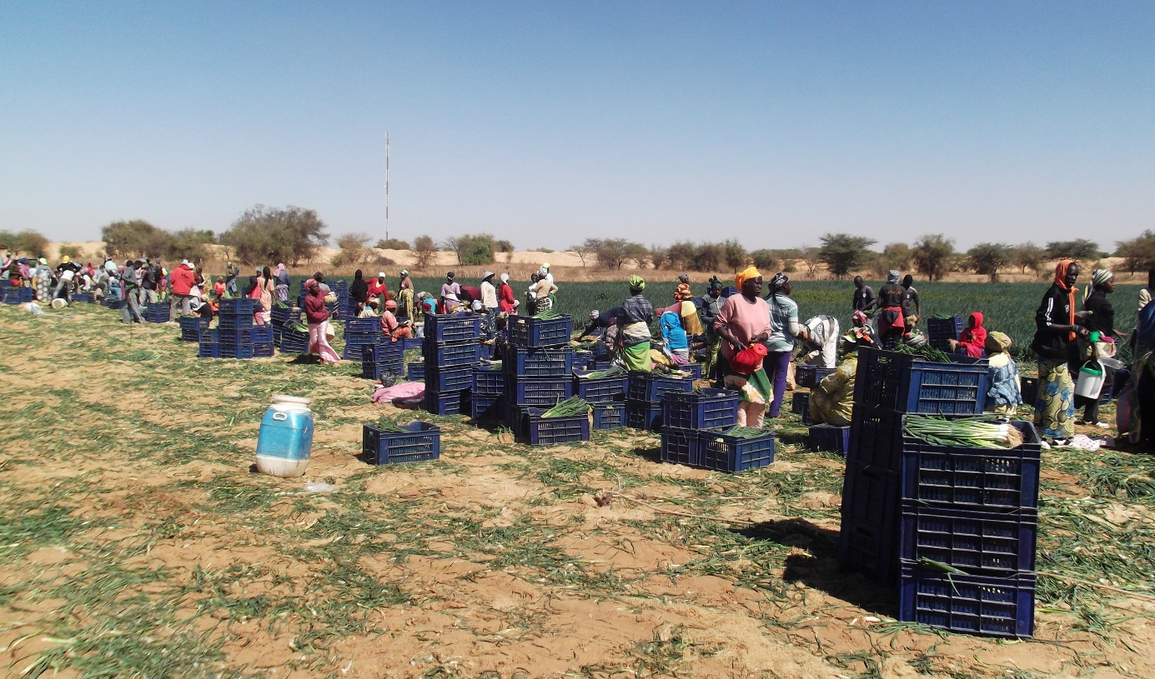
Moreover, the strategic position of the envisaged achievements will provide important support to the implementation of such large-scale continental programs as the Great Green Wall from Senegal to Djibouti, with a focus on combatting desertification.

Frameworks for Cooperation and Successful Sub-Regional Integration: The Case of the Shared Basins of OMVS and OMVG
Cooperation plays an obvious key role in border management policy. As part of the Organization for the Development of Senegal and Gambia River Basins (OMVS and OMVG), Senegal is collaborating with its neighbors following a regional integration approach based on sharing the benefits from concerted development. and common streams, thereby perpetuating centuries-old relationships established between communities living along the riverbanks. Senegal, through the OMVS, also housing the headquarters of the African Network of Basin Organizations (ANBO).
The Organization for the Development of the Senegal River (OMVS) constitutes a "success story" and successful model for joint management of transboundary basin water resources covering four (4) member states: Guinea, Mali, Mauritania, and Senegal.
The institutional and legal framework of the OMVS, which integrates the major concerns of the populations of each country, constitutes the base of this organization. Its founding texts, signed by the Heads of State and ratified by the State Parliaments, guarantee among other things:
- Acceptance by States and stakeholders of the internationalization of the river in their respective territories;
- The equal rights of Member States and their nationals to access water resources in the river;
- The obligation accepted by each State to submit, with prior approval of the basin organization, other projects likely to modify the characteristics of the river (i.e., hydrological regime ; health status of the water ; etc.);
- Co-financing by States of investments and charges related to mobilization of the rivers’s water resources, with the share of each State being indexed to the profits derived by that State;
- Acceptance by States of the common and indivisible ownership of the investments made by the OMVS.
.With the institutional framework, including the Conference of Heads of States and the Council of Ministers, the High Commission established the consultation and the consensus as a decision-making system to facilitate émergence of a basin consciousness and to develop the sense of sharing the resource and its long-term integrated sustainable management.
A regional infrastructure program was established by OMVS, including, among other achievements, the Diama anti-salt dam on the Senegal River, the Manantali hydroelectric dam and the Felou water-power station on the Bafing, the main tributary of the Senegal River. Other infrastructures of the same scope are planned on the medium term horizon.
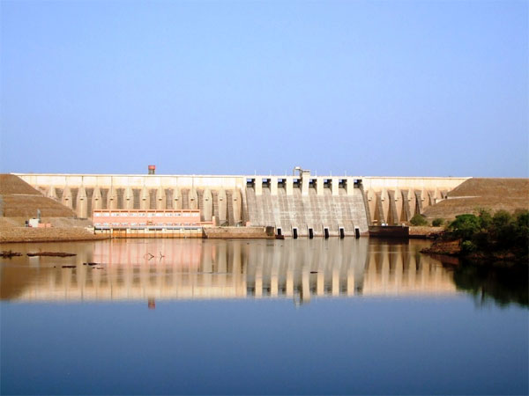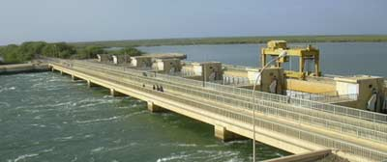
These different achievements made it possible to identify important potentialities impacting the economies of the member countries in their vital sectors, as follows:
− Irrigated agriculture is on track with, possible irrigation of 375,000 hectares of agricultural land, development of crops such as rice, onions, industrial tomatos, and sugar cane…
− Potable Water Supply (AEP) : The dams have improved the filling conditions of the lakes fed by Senegal River (Lac de Guiers in Senegal and Lake Rkiz in Mauritania), enabling drinking water to be supplied to both capitals, Dakar in Senegal and Nouakchott in Mauritania, as well as some of the secondary towns and riverside villages.
− Hydropower generation: Manantali hydroelectric dam and the Felou power plant offer 200 and 60 MW of installed capacity, respectively. Good prospects also exist for developing other sites with significant hydropower potential ;
− Navigation on the Senegal River: Navigation on the Senegal River is the backbone of the Integrated Multimodal Transport System (SITRAM), the future mesh network of fluvial and land transport modes that will eventually allow a connection between the sea, Dakar-Bamako railway and the road networks of OMVS member countries ;
− Local development: the Integrated Water Resources Management Program (PGIRE) implemented by OMVS allowed develop action in order to impact daily lives of the populations of Senegal River Basin in the field of infrastructures, hydraulic health and fishing. The Program concretely initiated the movement towards "OMVS for the peoples."
As part of OMVG, joint programs with Member States are being developed, including the ongoing construction of the Sambagalou hydroelectric dam and the planned electricity interconnection network between Member States.
Senegal, through the World Water Forum Nine of Dakar 2021, intends to highlight this noteworthy experience of joint and concerted management of river basins of the sub-region to consolidate in a sustainable way the security and peace that reigns in such territories by reinforcing sub-regional cooperation and integration.

Concept Note synthesized by S. Diop, from the Academy of Sciences and Professor of University at UCAD – Dakar - Senegal in cooperation with Prof. A. Kane from UCAD – Dakar – Senegal, who provided part of the documentation.

